SCALE DRAWINGS
Pearson Edexcel - Tuesday 12 June 2018 - Paper 3 (Calculator) Foundation Tier

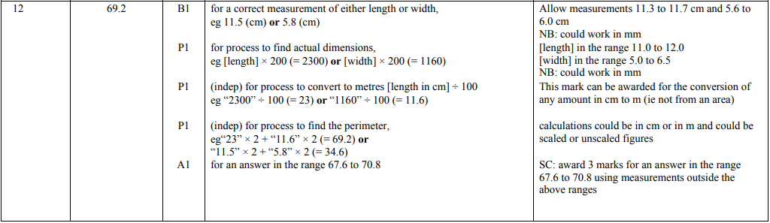

Pearson Edexcel - Wednesday 8 November 2017 - Paper 3 (Calculator) Foundation Tier

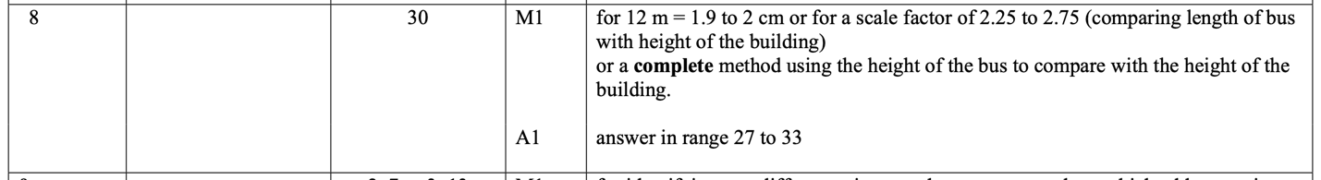

Pearson Edexcel – Specimen 2 - Paper 3 (Calculator) Foundation Tier

Pearson Edexcel – Specimen 1 - Paper 1 (Non-Calculator) Foundation Tier

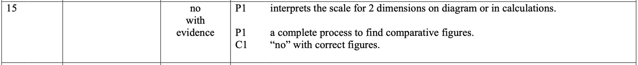

Pearson Edexcel – Specimen 1 - Paper 2 (Calculator) Foundation Tier

Pearson Edexcel – Specimen 1 - Paper 3 (Calculator) Foundation Tier

OCR – Tuesday 03 November 2020- Morning - Paper 1 (Calculator) Foundation Tier

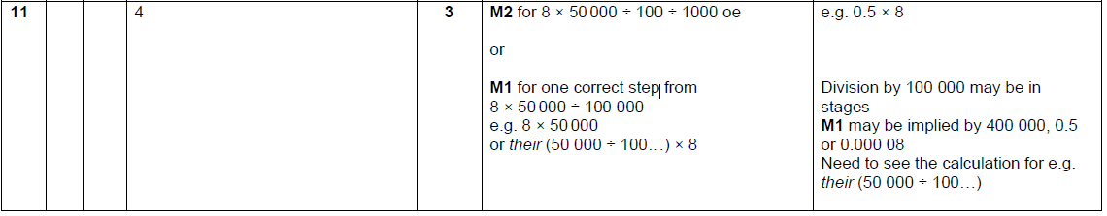

OCR Thursday 07 November 2019- Morning (Non-Calculator) Foundation Tier
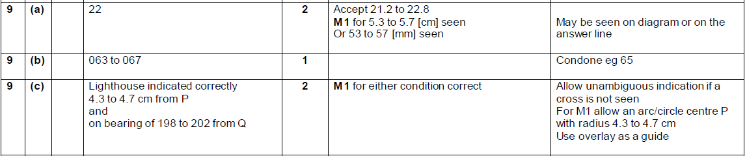

OCR Thursday 07 November 2019- Morning (Non-Calculator) Foundation Tier
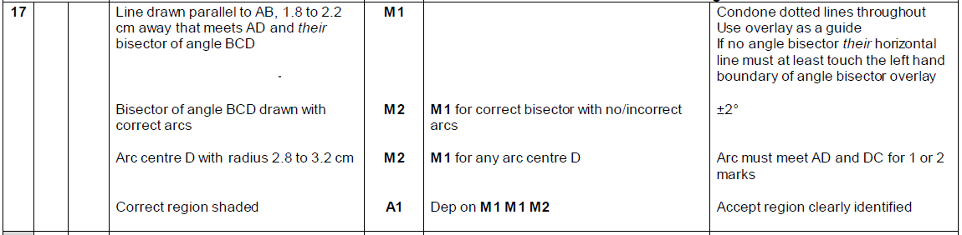

OCR Monday 12 November 2018 – Morning (Calculator) Foundation Tier
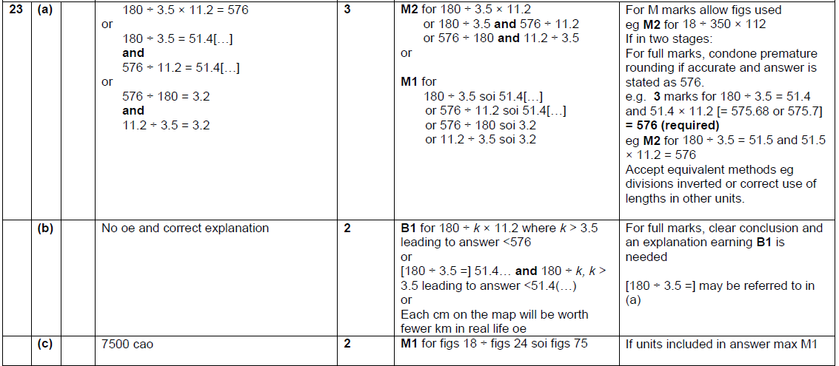

OCR Monday 24 May 2018 – Morning (Calculator) Foundation Tier
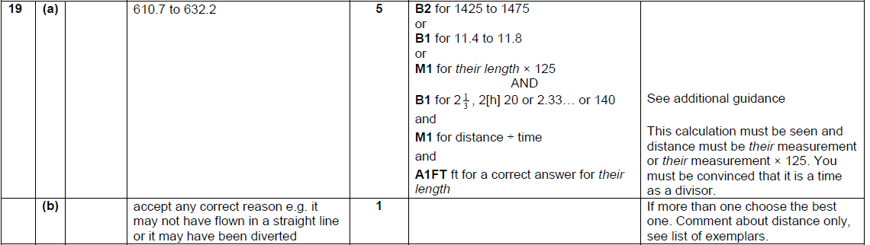

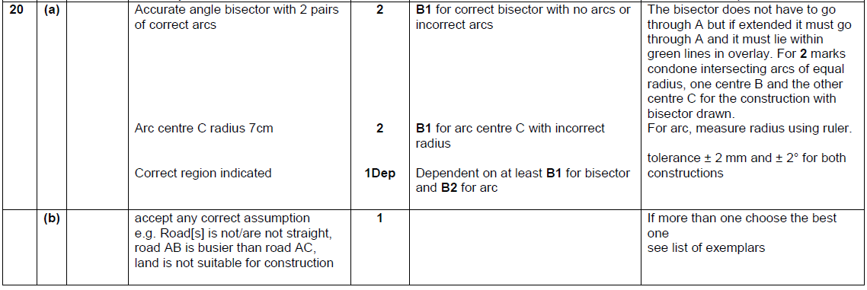

OCR Thursday 2 November 2017– Morning (Calculator) Foundation Tier
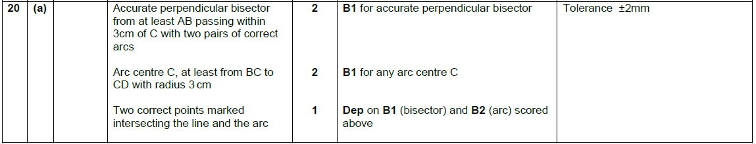

Pearson Edexcel –Sample Papers - Paper 2 (Calculator) Foundation Tier

OCR Thursday 25 May 2017 – Morning (Calculator) Foundation Tier

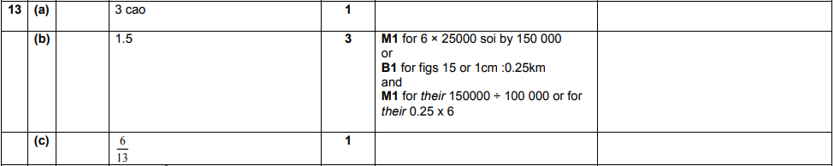
AQA Thursday 4 June 2020 – Morning (Calculator) Foundation Tier

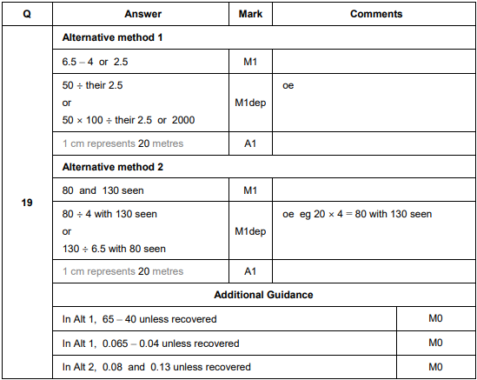
AQA Thursday 6 June 2019 – Morning (Calculator) Foundation Tier

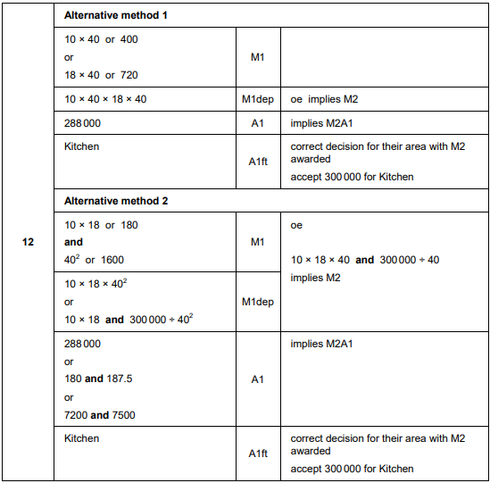

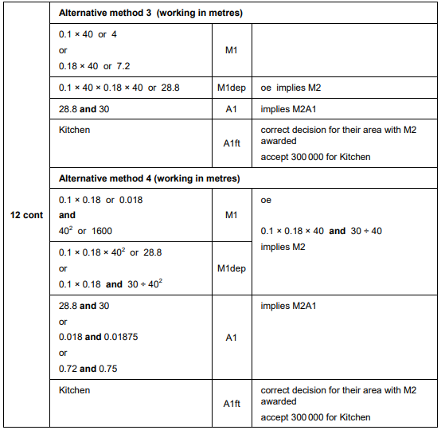
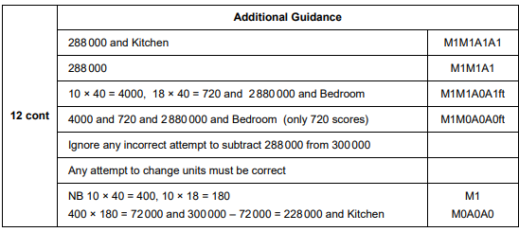

AQA Monday 12 November 2018 – Morning (Calculator) Foundation Tier

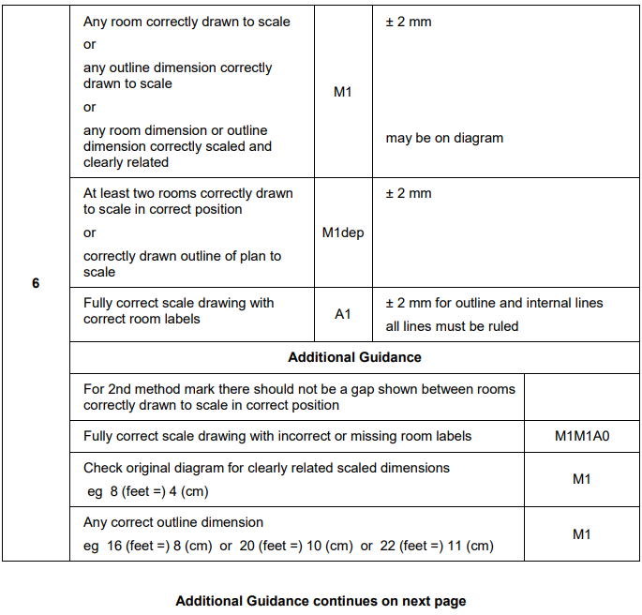
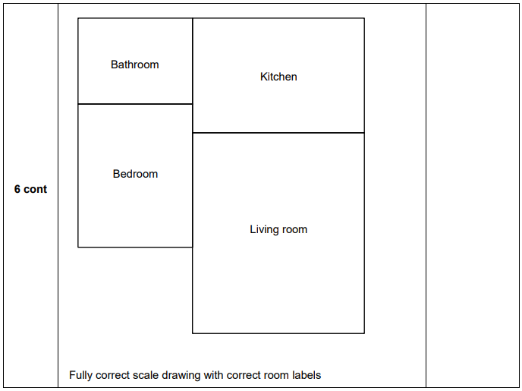
AQA Monday 12 November 2018 – Morning (Calculator) Foundation Tier

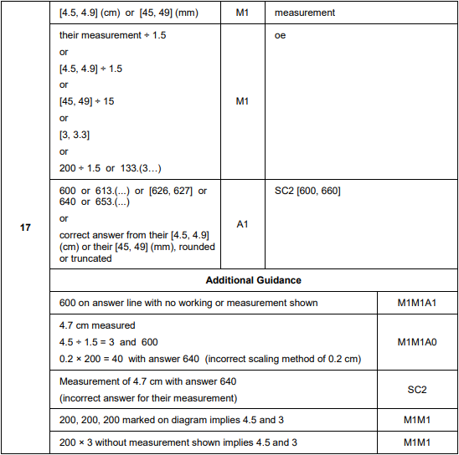
AQA Thursday 24 May 2018 – Morning (Non-Calculator) Foundation Tier

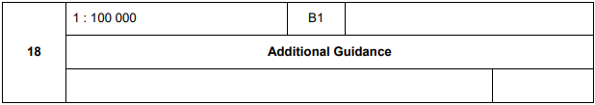

AQA Tuesday 12 June 2018 – Morning (Calculator) Foundation Tier

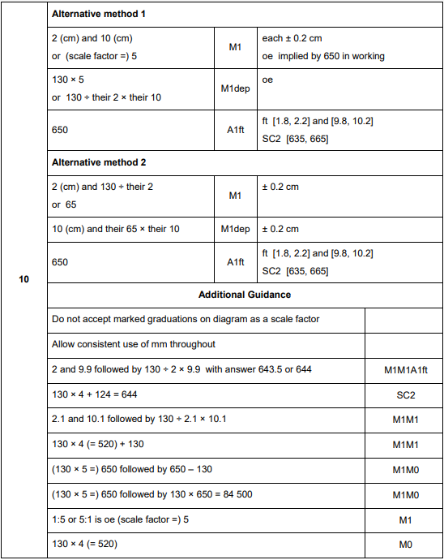

AQA Tuesday 12 June 2018 – Morning (Calculator) Foundation Tier

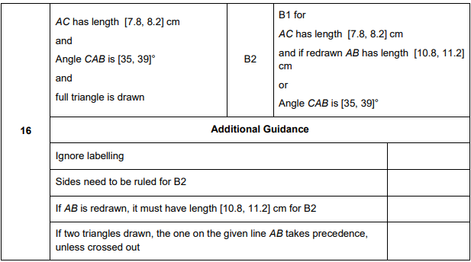
AQA Wednesday 8 November 2017 – Morning (Calculator) Foundation Tier

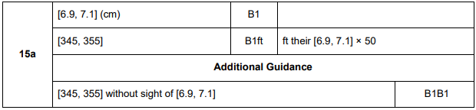
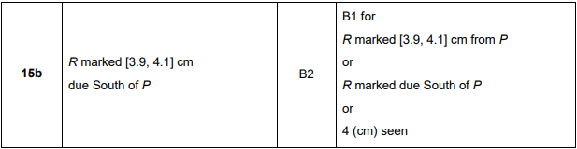

AQA Thursday 8 June 2017– Morning (Calculator) Foundation Tier

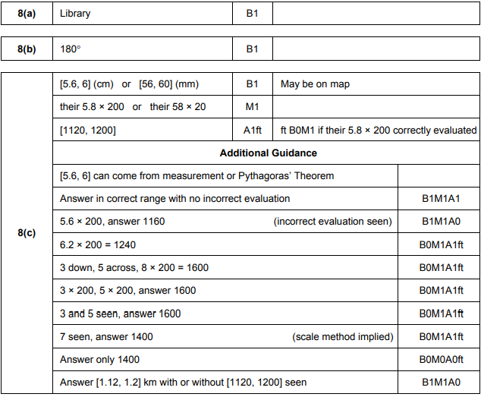
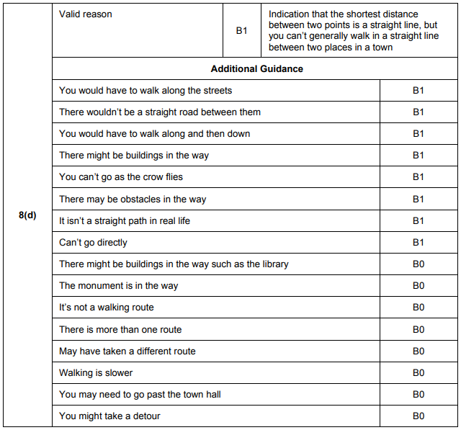
AQA Sample Paper 2– Morning (Calculator) Foundation Tier

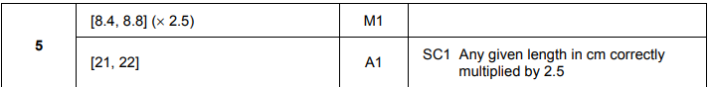

AQA Sample Paper 2– Morning (Calculator) Foundation Tier

